Gothic Nature: New Directions in Ecohorror and the EcoGothic

REFERENCING AND FORMATTING GUIDELINES

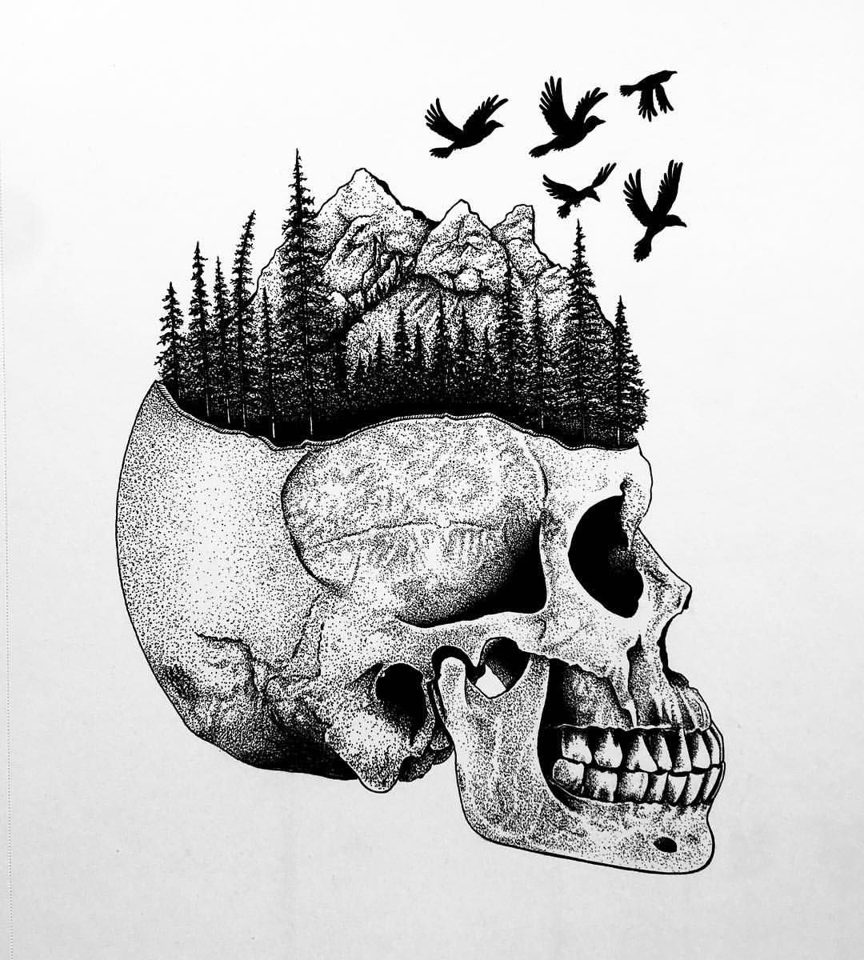

CONTENTS

Formatting/Layout 3

General 3
Title and Name for the Articles 3
Abstract 3
Subheadings 3
Paragraphs 3
Quotations 3
Biographies 4
Bibliography 4

Referencing/Style Guidelines 5

Harvard Style of Referencing 5
General 5
In-Text References 5
In-Text Direct Quotations 6

Bibliography 8

Books 8
Essay in a Collection 8
Journals 9
Websites 9
Newspaper Articles 10
Film 10

Footnotes 10

Reviews 11
Book Reviews 11
Film/TV Reviews 11

FORMATTING/LAYOUT:

General:
- Font: Time New Roman, size 12.
- 1.5 spacing.
- Justify entire document (except for bibliography).
- Include page numbers, centre-bottom.

Title and Name for articles:
- Title first: bold, centre.
- Author name second: centre, italicise.

Abstract
- Include abstract after title/name and immediately before the essay begins. The word ‘Abstract’ should be in bold and this paragraph should be indented on both sides by 0.63cm.

Subheadings
- Bold, align left.

Paragraphs
- Indent the first sentence of each paragraph, except those following titles or subheadings.
- Separate each paragraph with a space.

Quotations
- Use single inverted commas. Use double inverted commas for a quote within a quote. E.g. ‘…what constitutes “normal” monstrosity…’
- Longer quotations should also use single inverted commas and be indented on both sides by 1.27cm.

Biographies
- Biographies of 150 words come after the essay, but before bibliography.
- ‘Biography’ in bold.
- Name of the author in bold.

Bibliography
- Align left.
- Alphabetical order by surname.
- End all references with a full stop.

- One space between each reference.
- When more than one work by an author, list the most recent first. Use underscores to mark repeated name.

E.g.:

Radcliffe, A. (2009) The Romance of the Forest. Chard, C. (ed.) New York, Oxford.
__________ (2000) On the Supernatural in Poetry. In: Clery, E.J & Miles, R. (eds.) Gothic Documents, A Sourcebook 1700-1820. New York, Manchester University Press, pp.
163-171.

REFERENCING/STYLE GUIDELINES
Note: Gothic Nature follows the Harvard style of referencing. This is essentially a two-part process:
- Citation in the text: within your article, always indicate the source used following a direct quote or summary.
- Bibliography: a complete list of all the cited references and any other material consulted with full bibliographical details.

***We have endeavoured to summarise the Harvard referencing style here as a useful quick reference. For further details, please see the style guide in full: https://www.imperial.ac.uk/media/imperial-college/administration-and-support-services/library/public/Harvard.pdf). ***

GENERAL
- UK spelling throughout. (E.g. stylised, not stylized; theorise, not theorize).

- For consistency, we use ‘ecoGothic’ and ‘ecohorror’ (not ecogothic, eco-horror, etc.)

- Use the full name of all authors/critics the first time they are mentioned.
- Include the year of all texts (books, films, etc.) after first mention in parentheses. (E.g. ‘In The Blair Witch Project (1999) we see…’)
- Possessive forms: if the noun ends in ‘s’ follow with apostrophe. (E.g. Harris’, not Harris’s; Thomas’, not Thomas’s).

IN-TEXT REFERENCES

- Referencing one author.

Rule:

Sentence referring to a critic’s ideas (Surname, year).

or

Critic’s name (year) has these ideas…

Example:
We are haunted by our darker historical pasts (Morgan, 2001).

or

Morgan (2001) has explored the idea that we are collectively haunted by our historical pasts.

- Referencing 2-3 authors.

Same as with one author, but list all names and use ampersands. E.g.: (Smith & Hughes, 2013) or (Broadbent, Dardenne, & Smith, 2002).

- Referencing 4+ authors.

Use ‘et al’ after the first author’s name. E.g. (Kinane, et al., 2004).

- Citing works from the same author written in the same year.

In this case, use a lower-case letter to differentiate between the works and reflect in your bibliography. E.g. (Mann, 2000a; Mann, 2000b).

- Citing from essays in an edited collection.

Use the surname of the chapter author, not the surname of the editor. E.g. if quoting an essay by Kevin Corstorphine in Ecogothic, which is edited by Andrew Smith and William Hughes, you use Corstorphine’s surname: (Corstorphine, 2013).

- Secondary referencing.

If the primary source is not available and you are referring to one author referring to another author’s work: ‘According to Duffy (1992) as cited by Trieu (2000)…’

IN-TEXT DIRECT QUOTATIONS

- Cite the year in parenthesis after the critic’s name is mentioned and the page number after the quotation.

Examples:

Morgan (2001) uses the term ‘heritage noire’ (p. 28) to describe this.

Lynn Voskuil (2017), in her study of nineteenth century orchid literature, demonstrates ‘the readiness of many Victorians to conceive of boundaries between species as fluid rather than absolutely fixed’ (p.20).

- If the critic’s name is not mentioned, put the full reference after the quotation.

Examples:

This has been described as ‘heritage noire’ (Morgan, 2001: p. 28).

The setting is simultaneously enchanting and menacing: it is ‘inherently contradictory’ (Walker, 2019: p. 9).

- For longer quotations, indent by 1.27cm on each side, use single quotation marks, and include the reference at the end. Include a space above and below the quotation, to make clear that the quotation stands alone.

Examples:

This is best summed up by Aldana Reyes’ (2015) description of the Gothic body:

‘Gothic bodies produce fear through their interstitiality: they are scary because they either refuse human taxonomies or destabilise received notions of what constitutes a “normal” or socially intelligible body.’ (p.5)

or

Gothic bodies in themselves are key sources of terror:

‘Gothic bodies produce fear through their interstitiality: they are scary because they either refuse human taxonomies or destabilise received notions of what constitutes a “normal” or socially intelligible body.’ (Reyes, 2015: p. 5)

This is no longer a moral question, but one that renders morality and thus human agency meaningless:
‘Thinking the human at Earth magnitude is utterly uncanny: strangely familiar and familiarly strange. It is as if I realize that I am a zombie – or, better, that I’m a component of a zombie despite my will. Again, every time I start my car I’m not meaning personally to destroy lifeforms – which is what ‘destroying Earth’ actually means. Nor does my action have any statistical meaning whatsoever. And yet, mysteriously and disturbingly, scaled up to Earth magnitude so that there are billions of hands that are turning billions of ignitions in billions of starting engines every few minutes, the Sixth Mass Extinction event is precisely what is being caused. And some members of the zombie have been aware that there is a problem with human carbon emissions for at least sixty years.’ (Morton, 2016: p. 35)

- Ellipsis: if using ellipses to cut unnecessary sections of text, use square brackets for these. E.g. ‘Gothic bodies […] destabilise received notions of what constitutes a “normal” or socially intelligible body’.

BIBLIOGRAPHY
Note: please pay careful attention to punctuation.

BOOKS
Rule:
Surname, Initial. (Year) Book Title in Italics. Place of publication, publisher.
Example:
Fogle, R. H. (1964) Hawthorne’s Fiction: The Light and the Dark. Norman, University of Oklahoma Press.

ESSAY IN A COLLECTION
Rule:
Surname, Initial. (YEAR) Title of the Essay. In: Editor surname, Initial. (ed.) Name of Edited Collection. Place of Publication, Publisher, pp.

Example:
Dennis, J. (1939) The Grounds of Criticism in Poetry. In: Hooker, E. N. (ed.) The Critical Works of John Dennis. Baltimore, Johns Hopkins University Press, pp. 40-62.

JOURNALS

Journals in print:
Rule:
Surname, Initial. (YEAR) Title of Essay. Name of Journal. Issue (volume), page numbers.
Example:
Del Principe, D. (2014) Introduction: The Ecogothic in the Long Nineteenth Century. Gothic Studies. 16 (1), pp. 1-9.

Journals online:

Rule:
Surname, Initial. (YEAR) Title of Essay. Name of Journal. Issue (volume), page numbers. Available from: http://www.websitehere.html [Accessed day month year].

Example:

ééErrami, M. & Garner, H. (2008) A Tale of Two Citations. Nature. 451 (7), 397-399. Available from: http://www.nature.com/nature/journal/v451/n7177/full/451397a.html [Accessed 20th January 2015].

WEBSITES
Rule:
Surname, Initial (use corporate author if not individual author or editor is named). (YEAR) Title of Article. Available from: http://www.websitehere.html [Accessed day month year].
Example:
Giaimo, C. (2016) The Hidden Signs that Mark Britain’s Ghost Forests. Available from: https://www.atlasobscura.com/articles/the-hidden-signs-that-mark-britains-ghost-forests [Accessed 2nd July 2017].

NEWSPAPER ARTICLES
Rule:
Journalist surname, initial, Name of Newspaper, full date published D/M/Y, Title of Article.
Example:
Walsh, K. The Guardian, 20/02/2012. Climate Change Evidence Undeniable.

FILM
Rule:
Title of Film. (YEAR) [Medium]. Director surname, initial. dir. Place of production: production company.
Example:
Jug Face. (2013) [Film]. Kinkle, C. C. dir. USA: Modernciné.

FOOTNOTES
- Footnotes should always appear after punctuation (E.g. like this,¹ not like this¹.)

REVIEWS
Book Reviews
- Title: centre, bold.
Book author name, Title of Book Reviewed
- Publishing information: centre and in parenthesis. (Place of publication: publisher, year).
- Reviewer’s name below, align right.

Example:
Cherie Dimaline, The Marrow Thieves
(Toronto: Cormorant Books, 2017)
Reviewer name here.

Begin review here.

Film/TV Reviews
- Creator/director, title of film/series being reviewed: centre, bold.
- Production information centre and in parenthesis. (Place of production: production company, year).
- Reviewer’s name below, align right.

Example:
Jug Face
(Chad Crawford Kinkle: Modernciné, 2013)
Reviewer name here.

Begin review here.

